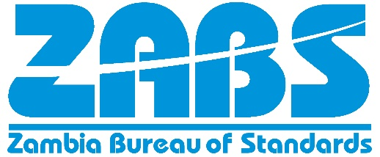

Theme: "Empowering Consumers through Standardisation to achieve their rights to safe Quality Goods and Services"

Entry Rules and Conditions

- This competition is open to students from institutions of higher learning from across Zambia below of the age 35 years

- Length of essay: Essays should be between 1000 and 1200 words

- Presentation: Essays should be double spaced and presented in Century Gothic, font size 12

- Language of essay: Essays must be submitted in English

- Information on the author: Authors may use up to 50 words to describe themselves. Information should include their names, course and year of study, name and town where the university/college is located. (N.B: This will not be part of the 1000-1200 words)

- Addresses on the first page of the essay together with the title of the essay and information on the author. Also attach a copy of the NRC or passport and a completely filled registration form that can be downloaded from the ZABS website.

- Contacts of authors: Authors should provide us with their postal, physical, telephone and email

- Eligibility: The following essays are not eligible for this competition:

- Essays that have been shown or accepted for other competitions.
- Essays that have been published in any form.
- Essays that focus on the work of a particular person, organization or brand name.
- Participants are only allowed to submit one essay

About the theme
Every year the world marks World Consumer Rights Day on 15th March, celebrated every year for raising global awareness about consumer rights and needs and for the standardisation community, to highlight how Standards facilitate the safeguarding of the Consumers Rights and Interests and What consumers want from products and services and why consumer participation in standards improves consumer responsive products and services. It’s also a day to demand that the rights (including the following) of consumers are respected and protected:

- Access to basic goods and services necessary for survival
- Protection from hazardous products or services
- Information about products and services
- Freedom to choose from a variety of quality products and services
- Voice a complaint about a product or service
- Consumer education and representation

The Consumer protection agenda has four main objectives: improving consumer safety; enhancing knowledge; improving implementation, stepping up enforcement and securing redress as well as aligning rights and key policies to economic and societal challenges (Valant et al., 2015). In this respect, the consumer protection framework is envisaged to cover a wide range of institutional mechanisms including the following (UNCTAD, 2017): National consumer policy; Designated consumer protection agency; Consumer laws; Codes or soft law complementary to consumer protection laws and setting out agreed principles for consumer protection and responsible business behaviour by particular business sectors; Consumer redress mechanisms; Systems for monitoring and surveillance; Mechanisms for compliance or enforcement; Consumer education and information programmes; International cooperation and networking.
What the Organisers are looking foR - Not Necessarily in the Order Below:
There are different areas on empowering consumers through standardisation to achieve their rights to safe quality goods and services...
Introduction
General understanding of standards and standardisation, and the relation with consumers
Problems facing consumers
Challenges being faced by consumers, and general understanding of challenges
Solutions and policy
Solutions provided through the implementation of standards and policy strategies developed nationally or continentally to address challenges of consumers with relation to the theme
Conclusion
Precise conclusion with your personal comment

Winners in the National Essay Competition will represent Zambia at the Regional and Continental ARSO Essay Writing Competition

Entries should be sent to cnzali@zabs.org.zm
Deadline for submission: Monday 11th March 2023

