DZS 1326 2026 FIRST EDITION
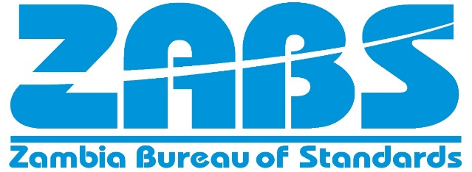
For Safety and Quality Assurance

Zambian Standard

HAIR SHAMPOO SOAP BASED - Specification

ZAMBIA BUREAU OF STANDARDS

Amendments issued since publications

Amdt No. | Date | Text affected

COPYRIGHT PROTECTED DOCUMENT

© ZABS 1990

All rights reserved. Unless otherwise specified, no part of this publication may be reproduced or utilized in any form or by any means, electronic or mechanical, including photocopying and microfilm, without permission in writing from Zambia Bureau of Standards

DATE OF PUBLICATION

This Zambian Standard has been published under the authority of the Bureau on 1990-03-31.

ZAMBIA BUREAU OF STANDARDS

The Zambia Bureau of Standards is a statutory organization established by the Standards Act, Cap 416 of 1994, for the preparation and promulgation of Zambian Standards.

REVISION OF ZAMBIAN STANDARDS

Zambian Standards are revised, when necessary, by the issue either of amendments or of revised editions. It is important that users of Zambian Standards should ascertain that they are in possession of the latest amendments or edition.

CONTRACT REQUIREMENTS

A Zambian Standard does not purport to include all the necessary provisions of a contract. Users of Zambian Standards are responsible for their correct application.

TECHNICAL COMMITTEE RESPONSIBLE

The preparation of this Zambian Standard was undertaken by Cosmetics and Hygienic products Technical Committee (CHD/1) on which the following organization were represented:

_____________________________________________________________________

ZAMBIA BUREAU OF STANDARDS, P.O. BOX 50259, LUSAKA

FORWORD

This National Standard has been prepared in accordance with the procedures of ZABS. All users should ensure that they have the latest edition of this publication as normative documents are revised from time to time.

No liability shall attach to ZABS or its Director, employees, servants or agents including individual experts and members of its Technical Committees for any personal injury, property damage or other damages of any nature whatsoever, whether direct or indirect, or for costs (Including legal fees) and expenses arising out of the publication, use of, or reliance upon this ZABS publication or any other ZABS publication.

Compliance with a Zambian standard or other normative document does not of itself confer immunity from legal obligations

DRAFT ZAMBIAN STANDARD DZS 1326 2026

Hair shampoo Soap based — Specification

Scope

This Zambian Standard specifies requirements, sampling and test methods for soap-based hair shampoo.

Normative references

The following documents are referred to in the text in such a way that some or all of their content constitutes requirements of this document. For dated references, only the edition cited applies. For undated references, the latest edition of the referenced document (including any amendments) applies.

ZS 954, (all parts), Cosmetics and cosmetic products

ZS 185-16, Cosmetics — Analytical methods — Part 16: Determination of lead, mercury and arsenic content

ZS 185-17, Cosmetics — Analytical methods — Part 17: Determination of pH

ZS 185-27, Cosmetics — Analytical methods — Part 27: Determination of total fatty substance by gravimetric method

ZS 185-20, Cosmetics — Analytical methods —:Part 20: Determination of lather volume (foaming power)

ZS 185-28, Cosmetics — Analytical methods —:Part 28:Determination of free caustic alkali

ISO 673, Analysis of soap — Determination of ethanol insoluble matter

ISO 21149, Cosmetics Microbiology Enumeration and detection of aerobic mesophilic bacteria

ISO 18416, Cosmetics — Microbiology — Detection of Candida albicans

ISO 22717 Cosmetics — Microbiology — Detection of Pseudomonas aeruginosa ISO 22718, Cosmetics — Microbiology — Detection of Staphylococcus aureus ISO 24153, Random sampling and randomisation procedures

Terms and definitions

ISO and IEC maintain terminological databases for use in standardization at the following addresses:

— IEC Electropedia: available at http://www.electropedia.org/

— ISO Online browsing platform: available at http://www.iso.org/obp

3.10
antibacterial activity
ability of a bathing soap to inhibit the growth or destroy bacteria and other harmful microorganisms (germs). This activity is commonly found in products designed to prevent infections and promote hygiene, including antibacterial agents, antiseptic agents, and anti-germ formulations.

Classification

Soap-based shampoo shall be classified into four types:

  - general purpose shampoo — this shall be for "dry", "oily" or "normal" hair, and shall be indicated so;

  - treatment/conditioning shampoo;

  - baby shampoo; and

  - neutralizing shampoo.

Requirements

Ingredients

    - All ingredients used, including pigments and colours, shall comply with ZS 934 .

    - All essential oils/herbs used shall comply with the relevant standards.

    - A list of ingredients conventionally used in the formulation of shampoos is given for guidance in Annex A.

    - The product shall contain acceptable amounts of the ingredients necessary to effect the intended end use performance as stipulated on the label.

    - All active ingredients including anti-bacterial or anti-dandruff agents, shall be named. Any further information concerning the active ingredients shall be supplied by the manufacturer on request.

    - For baby shampoos, the active ingredients, perfume and other ingredients shall be of such nature and in such amounts as to leave the final baby product mild in nature. This is due to the sensitive nature of baby skin.

General requirements

    - The product shall be in the form of liquid, emulsion, gel or paste.

    - The product in the form of a paste shall be free from any agglomeration.

    - The product in the form of a liquid shall be clear/transparent and free from any sediment.

    - The product in the form of an emulsion shall be homogenous with no visible signs of phase separation or emulsion breakage.

    - The product may be coloured and/or perfumed.

    - The product shall have no undesirable effect on the natural colour of the hair. (This does not include hair already treated with hair dyes).

    - The product shall be non-irritating to the scalp and the skin.

    - The product shall impart all the effects claimed, for example, dandruff control.

    - Any product containing ingredients for which medicinal claims are made shall be registered with the ZAMRA.

Specific requirements

    - The shampoo shall comply with the requirements given in Table 1 when tested in accordance with the methods prescribed therein.

Table 1 — Requirements for soap-based hair shampoo

S/No. | Characteristic | Requirements |  |  |  | Test Method
S/No. | Characteristic | Neutralising | Baby | Treatment/ conditioning | General purpose | Test Method
i. | Total fatty matter, % m/m, min. | 10.0 | 10.0 | 10.0 | 10.0 | ZS 185-27
ii. | Lather volume for 2 % solution, mL, min. | 100 | 100 | 100 | 100 | ZS185-20
iii. | Free caustic alkali, as NaOH or KOH, % m/m, max. | 0.01 | 0.01 | 0.01 | 0.01 | ZS 185-28
iv. | pH at 27oC ± 2oC, range | 4 - 5 | 5 – 7 | 4 – 7 | 5 – 9 | ZS 847-17
v. | Matter insoluble in alcohol,  % m/m, max. | 3.0 | 3.0 | 3.0 | 3.0 | ISO 673
vi. | Antibacterial activity | To pass test | To pass test | To pass test | To pass test
Note: Alternative test methods such as ASTM E1174 and EN 1276 factoring log reduction are also accepted to support

    - The products shall comply with the limits for heavy metal contaminants in accordance with Table 2 when tested in accordance with the methods prescribed therein.

Table 2 — Limits for heavy metal contaminants for soap-based hair shampoo

S/No | Characteristic | Limit | Test Method
i. | Lead, mg/kg, max. | 10 | ZS 185-16
ii. | Arsenic, mg/kg, max. | 2 | ZS 185-16
iii. | Mercury, mg/kg, max | 1 | ZS 185-16
iv | Cadmium | 5
NOTE 1 The total amount of heavy metals as lead, mercury and arsenic, in combination, in the finished product should not exceed 10 mg/kg.

NOTE 2 The heavy metals including lead, mercury and arsenic may be as a result of contamination during processing and should not be deliberately added as ingredients.
    - The product shall also comply with the microbiological limits given in Table 3 when tested in accordance with the methods prescribed therein.

Table 3 ⎯ Microbiological limits for soap-based hair shampoo

S/No. | Micro-organism | Maximum limit | Test method

i. | Total viable count in CFU/ g or CFU/mL, max.  a). Adult products b). Baby products | 1,000  100 | ISO 21149
ii. | Pseudomonas aeruginosa in 1 g | Not detectable | ISO 22717
iii. | Staphylococcus aureus in 1 g | Not detectable | ISO 22718
iv. | Candida albicans in 1 g | Not detectable | ISO 18416

Packaging and labelling

Packaging

The product shall be packaged in suitable well-sealed containers that shall protect the contents and shall not cause any contamination or react with the product.

Labelling

Each package shall be legibly and indelibly labelled in English, or any other language as agreed to between the manufacturer and supplier with the following information:

    - type of shampoo
    - Name of all ingredient(s) in the product

    - an indication of antibacterial activity (where applicable)

    - Manufacturer’s name, address and a recognized trademark, if any
    - Net mass of the product.
    - Instructions for storage and use.
    - Batch number, in code or otherwise.
    - manufacturing date
    - Expiry date
    - country of origin
    - The container may also be marked with the ZABS Certification Mark.

NOTE.
Information about the ZABS Certification Mark may be obtained from the Zambia Bureau of Standards.

Sampling

Sampling shall be done in accordance with ISO 24153.

Annex A
(informative)

List of ingredients conventionally used in formulation of soap-based shampoo

Chelation agents

    - Sodium polyphosphates

    - Disodium salt of ethylenediamine tetra-acetic acid (EDTA)

Preservatives

    - Alcohols

    - Sorbic acid

    - Ester of p-hydroxybenzoic acid

    - Imidazolidinyl urea

    - Kathon CG (Methylchloroisothiazolinone and methyl-isothiazoline)

Emollients

Lanoline and its derivatives

Thickening agents/viscosity enhancers

    - Sodium carboxymethyl cellulose

    - Methyl isopropyl cellulose

    - Methyl cellulose

    - Methyl glycoside derivatives

    - Guar gum

Counter-irritants

    - Ethoxylated fatty alcohols

    - Ethoxylated fatty esters

    - Methyl glycoside derivatives

Conditioners

    - Polyquaternary ammonium compounds and monomeric quaternary ammonium compounds

    - Hydrolized proteins

    - Amphoterics

U.V. Stabilizers

Benzophenone derivatives

Other groups of ingredients

    - Perfumes

    - Dyes

Bibliography

      - EAS 842-1: 2017, Hair shampoo — Specification — Part 1: Soap based

      - ASTM E1174 Standard Test Method for Evaluation of the Effectiveness of Healthcare Personnel Handwash Formulations

DEAS 842-1: 2025

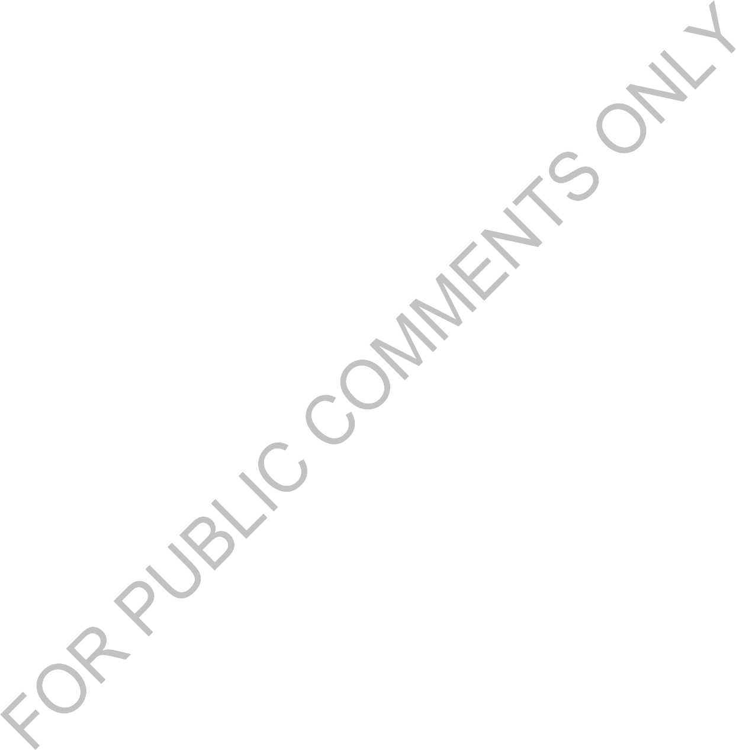

© EAC 2025 – All rights reserved

