DZS 264 2026
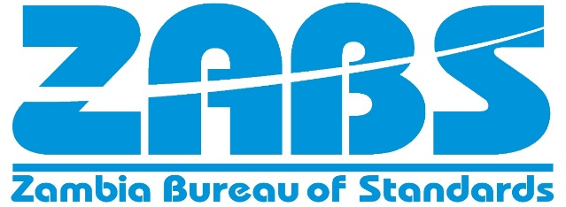
For Safety and Quality Assurance

Draft Zambian Standard

HAIR CREAMS, LOTIONS AND GELS - Specification

ZAMBIA BUREAU OF STANDARDS

Amendments issued since publications

Amdt No. | Date | Text affected

COPYRIGHT PROTECTED DOCUMENT

© ZABS 1990

All rights reserved. Unless otherwise specified, no part of this publication may be reproduced or utilized in any form or by any means, electronic or mechanical, including photocopying and microfilm, without permission in writing from Zambia Bureau of Standards

DATE OF PUBLICATION

This Zambian Standard has been published under the authority of the Bureau on XXXX.

ZAMBIA BUREAU OF STANDARDS

The Zambia Bureau of Standards is the Statutory National Standards Body for Zambia established under an act of Parliament, the Standards Act, No. 4 of 2017 of the Laws of Zambia for the preparation and promulgation of Zambian standards..
.

REVISION OF ZAMBIAN STANDARDS

Zambian Standards are revised, when necessary, by the issue either of amendments or of revised editions. It is important that users of Zambian Standards should ascertain that they are in possession of the latest amendments or edition.

CONTRACT REQUIREMENTS

A Zambian Standard does not purport to include all the necessary provisions of a contract. Users of Zambian Standards are responsible for their correct application.

TECHNICAL COMMITTEE RESPONSIBLE

The preparation of this Zambian Standard was undertaken by Cosmetics and Hygienic products Technical Committee (4/3) on which the following organization were represented:

Ministry of Health (Food and Drugs control Laboratories)
Competition and Consumer Protection Commission
Zambia Association for Consumers
Zambia Compulsory Standards Agency
Zambia Bureau of Standards

_____________________________________________________________________
ZAMBIA BUREAU OF STANDARDS, P.O. BOX 50259, LUSAKA

Contents Page
Foreword iv
- Scope 1
- Normative references 1
- Terms and definitions 1
- Requirements 2
  - Ingredients 2
  - General requirements 2
  - Specific requirements 2
  - Microbiological limits 2
  - Heavy metal contaminants 2
Packaging 3
- Labelling 3
- Sampling 3

FORWORD

This National Standard has been prepared in accordance with the procedures of ZABS. All users should ensure that they have the latest edition of this publication as normative documents are revised from time to time.

No liability shall attach to ZABS or its Director, employees, servants or agents including individual experts and members of its Technical Committees for any personal injury, property damage or other damages of any nature whatsoever, whether direct or indirect, or for costs (Including legal fees) and expenses arising out of the publication, use of, or reliance upon this ZABS publication or any other ZABS publication.

Compliance with a Zambian standard or other normative document does not of itself confer immunity from legal obligations

Introduction
Hair creams, lotions and gels are products used to enhance glossy appearance on the hair and condition the hair. It may contain additives which stimulate the scalp, moisturize, repair, strengthen, boost growth the hair or have anti-dandruff properties since hair creams, lotion and gels have different functionalities based on the added additives

DRAFT ZAMBIAN STANDARD DZS 263 2026

Hair creams, lotions and gels — Specification

Scope

This Zambian Standard specifies the requirements, sampling and methods of test for hair creams, lotions and gels.

It also applies to hair conditioners and setting lotions.

This Zambia standard does not cover hair sprays, hair sheens or hair oils.

This Draft Zambian standard does not cover hair creams, lotions and gels for which therapeutic claims are made.

Normative references

The following documents are referred to in the text in such a way that some or all of their content constitutes requirements of this document. For dated references, only the edition cited applies. For undated references, the latest edition of the referenced document (including any amendments) applies.

ZS 185 Methods or sampling and test for hair creams.
ZS 179 Methods for dermatological tests for cosmetic industry
ISO 18416, Cosmetics —Microbiology —Detection of Candida albicans
ISO 21149, Cosmetics --Microbiology --Enumeration and detection of aerobic mesophilic bacteria ISO 22717, Cosmetics —Microbiology —Detection of Pseudomonas aeruginosa
ISO 22718, Cosmetics —Microbiology —Detection of Staphylococcus aureus ISO 24153, Random sampling and randomization procedures

Terms and definitions

No terms and definitions are listed in this document.

ISO and IEC maintain terminological databases for use in standardization at the following addresses:

— ISO Online browsing platform: available at http://www.iso.org/obp

Requirements

Ingredients

All ingredients used including dyes, pigments and colours shall comply with all the parts of ZS 954.

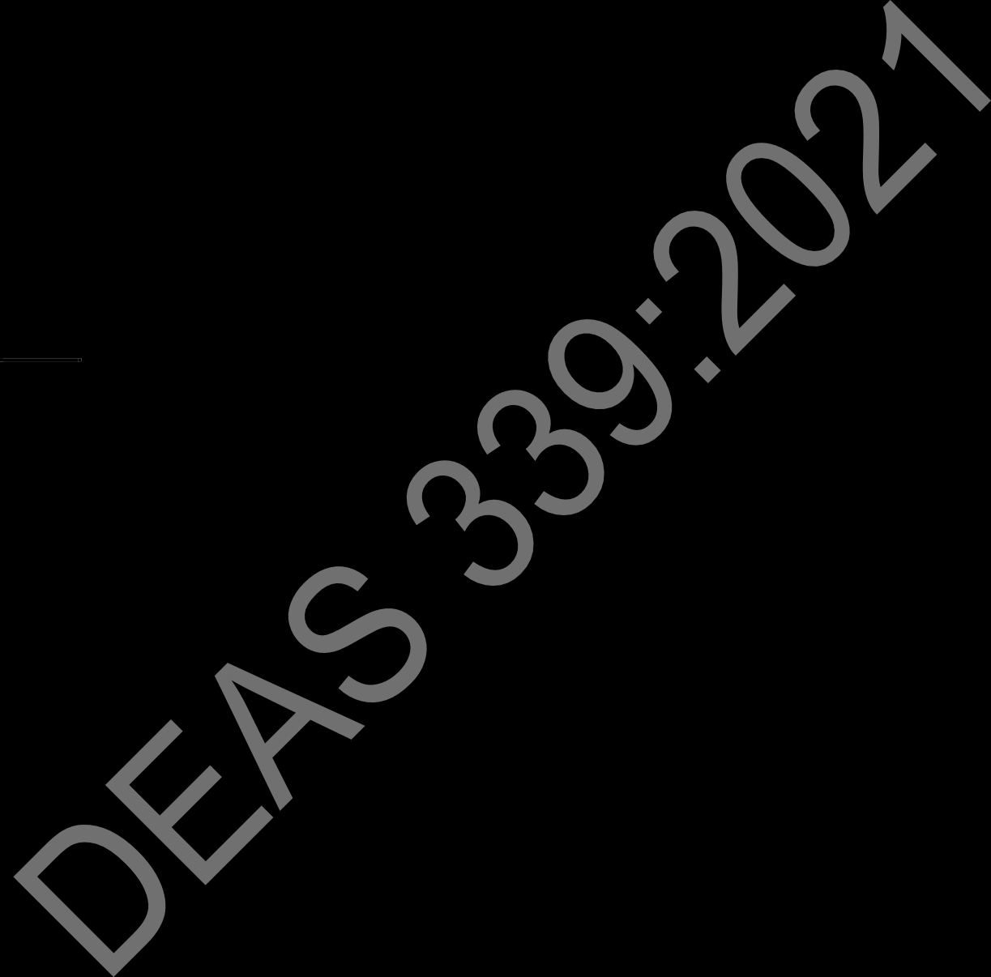
General requirements

    - The hair cream, lotion and gel shall be in the form of an emulsion and of a uniform colour showing no signs of separation nor visible impurities.

4.2.3 The product shall not be harmful to the scalp or hair when used as intended by the manufacturer.

Specific requirements

The hair cream, lotion or gel shall comply with the chemical requirements as specified in Table 1 when tested according to the specified methods of test.

Table 1 — Chemical requirements for hair creams, lotions and gels

S.No. | Characteristic |  | Requirements | Test method
i) | pH | Hair cream gel or lotion | 5 - 8 | ZS 185-4
i) | pH | Hair conditioners (rinse-off and leave-in) | 3 - 6 | ZS 185-4
ii) | Thermal stability |  | To pass test | ZS 185-3
iii) | Rancidity |  | To pass test | ZS 185-9

Microbiological limits

Microbiological limits shall comply with the limits specified in Table 2.

Table 2 — Microbiological limits for hair creams, lotions and gels

Micro-organisms | Limits | Test method
Total viable count for aerobic mesophyllic microorganisms CFU/g or CFU/ml, max. | 100 | ISO 21149
Pseudomonas aeruginosa | Not detected in 1 ml or 1 g of cosmetic product | ISO 22717  ISO 22718  ISO 18416
Staphylococcus aureus | Not detected in 1 ml or 1 g of cosmetic product | ISO 22717  ISO 22718  ISO 18416
Candida albicans | Not detected in 1 ml or 1 g of cosmetic product | ISO 22717  ISO 22718  ISO 18416
Escherichia coli | Not detected in 1 g of cosmetic product | ISO 21150

Heavy metal contaminants

The products shall comply with the limits for heavy metal contaminants in accordance with Table 3.

Table 3 — Limits for heavy metal contaminants for hair creams, lotions and gels

S.No. | Characteristic | Limit mg/kg,max | Test method
i) | Lead | 10 | ZS 185
ii) | Arsenic | 2 | ZS 185
iii) | Mercury | 1.0 | ZS 185
iv) | Cadmium | 2
NOTE The total amount of heavy metals as lead, mercury and arsenic, in combination, in the finished product should not exceed 10 mg/kg.

Packaging

The product shall be packaged in suitable well-sealed containers that shall protect the contents and shall not cause any contamination or reaction to the product.

Labelling

In addition, to the labelling requirements given in ZS 034, each package shall be legibly and indelibly marked with the product name as “Hair cream”, “Hair lotion” or “Hair gel”.

a) Name of all ingredients(s) in the product.
b) Manufacturer’s name, address and a recognised trade mark, if any
c) Net mass of the product.
d) Instructions for storage and use.
e) Batch number, in code or otherwise.
f Manufacturing date
g) Expiry date
h) The container may also be marked with the ZABS Certification Mark.

NOTE.
Information about the ZABS Certification Mark may be obtained from the Zambia Bureau of Standards.

Sampling

Sampling shall be carried in accordance with ISO 24153

